Project Documentation Phase

1. Introduction
The Project Documentation Phase involves recording all the important details of the Script-Controlled ACL project. It includes documenting the project requirements, design, development activities, testing results, ACL configuration, and final output.

2. Objective
- To prepare complete documentation of the project.
- To record the requirements and objectives of the system.
- To document the ACL configuration and script logic.
- To record the development and testing activities.
- To maintain the project results for future reference.

3. Activities Performed
- Documented the project introduction and objectives.
- Recorded the requirements and access-control conditions.
- Documented the project planning and development activities.
- Recorded the Script-Controlled ACL configuration.
- Documented the field-value-based access rules.

4. Expected / Produced Output
- Complete project documentation prepared.
- ACL configuration and script details documented.
- Development and testing results recorded.
- Screenshots and diagrams included.
- Access-control rules clearly documented.

Screenshot

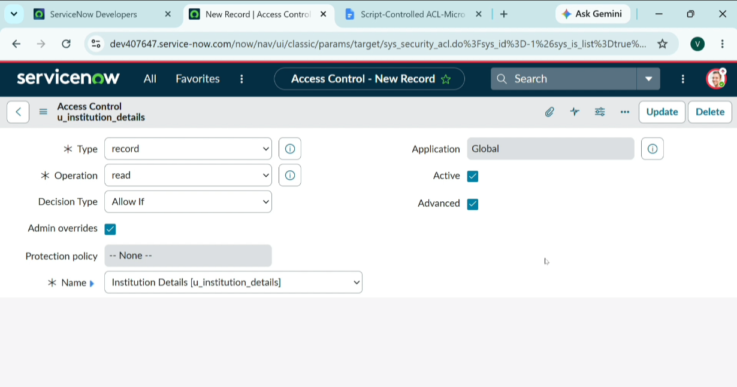
- Data Flow Diagram

